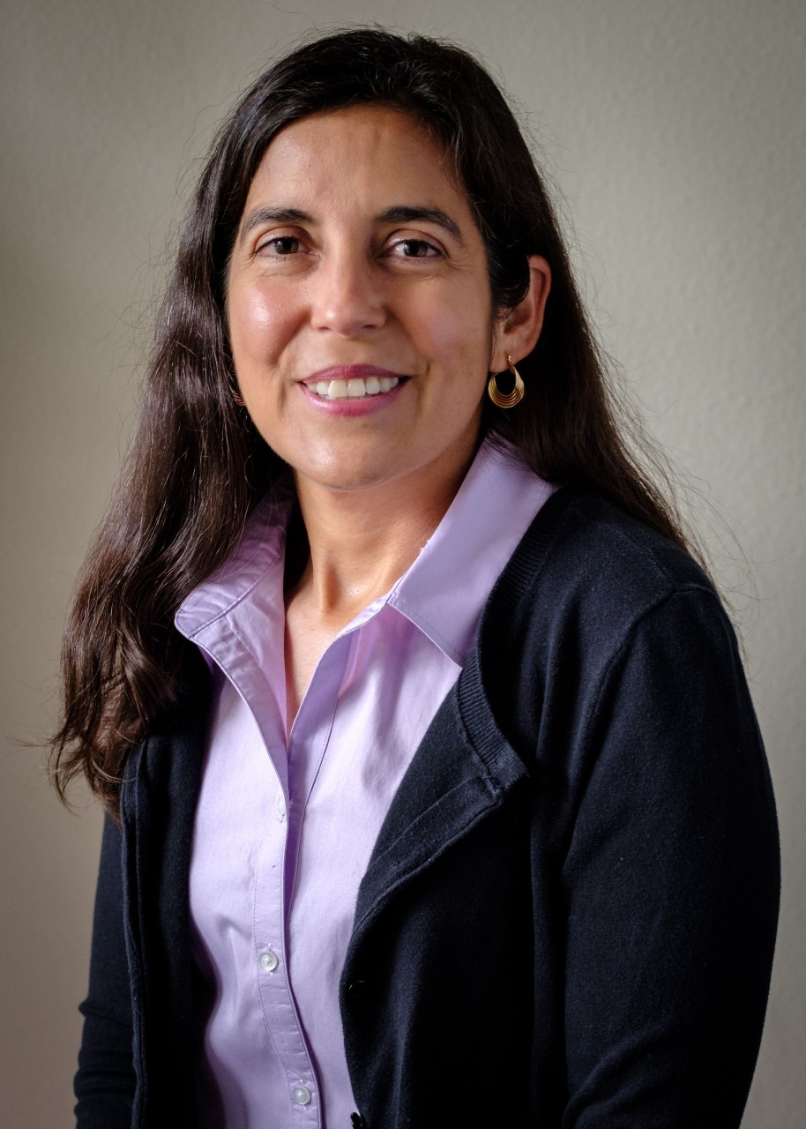
Cristy Gamez, Ph.D.

Dr. Cristy Gamez earned her degrees including a Doctorate in Clinical Psychology from the University of Houston. She is a licensed psychologist and the clinical coordinator for Easter Seals Greater Houston. Throughout her career, she has been involved with establishing and/or implementing programs to meet the needs of specific communities. Creating a mental health curriculum for dually diagnosed Native Americans, leading peer support training and implementation for Veterans, and establishing services for military-connected individuals and families have prepared her for her support role with VAST. She enjoys running, yoga, and hiking with her husband, two children, and their dogs.

