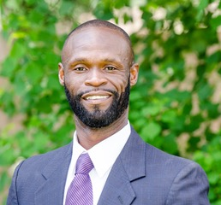
ROBERT GREEN

Robert Green, a United States Marine, enlisted at the young age of 18, in 1995. He began his journey as a private.. After active duty, Robert was discharged from the Marines with what others would think is, “a good life”. On the contrary, Robert was plagued with alcohol abuse, drug abuse, homelessness and worst of all, an arrest record as long as 30 incarcerations. As a result, in 2016, Robert was sentenced to five (5) years in the Texas Department of Criminal Justice (TDCJ).

Robert served three years of his five-year sentence. He was released in 2019. From that day, Robert has vowed to live a better life and to make it a passion to give back and contribute to helping others. Upon his release he joined a program called VAST where he was able to find the mentorship, guidance, and assistance with shelter, employment and clothing. Robert was able to transcend self-imposed limitations, gain clarity, boost his confidence and ignite his imagination with ideas and perspectives to lead a life with purpose.

In September 2020, Robert learned the Pressure/Soft Wash service and shortly thereafter founded XLR8 Pressure Washing Service, LLC. Robert’s philosophy is “Each One, Teach One.” Therefore, he is committed in employing those who have been incarcerated and released and having a difficult time in finding and securing employment. As such, his company is insured and bonded for such risk to his clients.

Despite all the obstacles Robert Green has faced, he has and still is proving to himself and others that no matter what mistakes you have made in life, with a positive attitude, a plan of action, determination and healthy relationship you can turn your life around and make your dreams become reality.

